CHAPTER THREE
RESEARCH METHODOLOGY
3.1 Introduction
This chapter presents the analysis of the proposed School Learning Management System (LMS). System analysis is an important phase in the Software Development Life Cycle (SDLC) because it involves examining the existing educational management processes, identifying their limitations, and determining the functional and non-functional requirements of the proposed system. The analysis provides a clear understanding of the problem domain and serves as the foundation for the system design and implementation presented in the subsequent chapter.
The existing system used by many educational institutions relies heavily on manual processes and fragmented digital solutions for managing academic activities such as student registration, course management, assignment submission, grading, communication, and record keeping. These approaches often result in inefficiencies, duplication of data, delayed dissemination of information, limited accessibility to learning resources, and challenges in monitoring students' academic progress. Such limitations negatively affect the quality of teaching, learning, and administrative decision-making.
The proposed School Learning Management System seeks to address these shortcomings by providing a centralized, web-based platform that integrates the major academic and administrative functions of an educational institution. The system enables administrators to manage users, departments, courses, and academic records; teachers to upload learning materials, create assignments and quizzes, record attendance, and assess students; and students to access course resources, submit assignments, participate in online assessments, and monitor their academic performance through a secure and user-friendly interface.
This chapter evaluates the feasibility of the proposed system from technical, operational, economic, and legal perspectives. It also identifies the functional and non-functional requirements that guide the development of the system. Furthermore, the chapter presents the system modelling techniques used to describe the behaviour and structure of the proposed LMS, including the Context Diagram, Data Flow Diagram (DFD), and Use Case Diagram. These models provide a visual representation of the interactions between users and the system, as well as the movement of data throughout the application.
The outcome of this analysis establishes the foundation for the system architecture, database design, user interface design, and implementation procedures discussed in Chapter Four. By thoroughly analysing the requirements of the proposed Learning Management System, the study ensures that the final solution effectively addresses the identified problems while meeting the needs of administrators, teachers, students, and other stakeholders within the educational environment.

3.2 Analysis of the Existing System
The existing academic management system used by many educational institutions is characterised by a combination of manual procedures and isolated digital applications. While some institutions utilise basic computerised systems for student registration and record keeping, many critical academic processes remain fragmented and inefficient. This lack of integration makes it difficult to manage academic activities effectively and limits timely access to information by administrators, teachers, and students. Studies have shown that fragmented educational information systems contribute to administrative inefficiencies, poor data accessibility, reduced collaboration, and challenges in managing teaching and learning activities (Almaiah et al., 2020; Salloum et al., 2019; Turnbull et al., 2021).
The existing system was analysed based on the major functional areas of academic management, as discussed below.
3.2.1 User Management
In the existing system, user accounts for administrators, teachers, and students are often created and managed manually. User information is frequently stored across multiple files or separate systems, making it difficult to maintain consistency and accuracy. The absence of automated Role-Based Access Control (RBAC) increases the risk of unauthorized access to sensitive information and complicates user administration. Research indicates that ineffective user management and weak access control mechanisms reduce system security, increase administrative workload, and negatively affect the adoption and usability of educational information systems (Almaiah et al., 2020; Salloum et al., 2019). Furthermore, integrated user management with clearly defined roles improves security, accountability, and operational efficiency in Learning Management Systems (Turnbull et al., 2021).
Weaknesses
- Manual creation and updating of user accounts.
- Inconsistent user information across different systems.
- Limited access control mechanisms.
- Time-consuming user administration.

3.2.2 Student Records Management
Student records such as personal information, academic history, enrolment details, attendance records, and examination results are often maintained using paper documents or spreadsheets. This approach makes retrieving, updating, and maintaining records difficult, especially as student numbers increase. Manual record management also increases the possibility of data duplication, loss, and human error. Studies have shown that reliance on manual and fragmented record-keeping systems reduces administrative efficiency, limits timely access to student information, and hinders effective academic decision-making (Bond et al., 2021; Almaiah et al., 2020). Furthermore, integrated Learning Management Systems provide centralized storage and management of student records, improving data accuracy, accessibility, and institutional efficiency (Turnbull et al., 2021).
Weaknesses
- Difficulty retrieving historical records.
- High risk of data duplication and inconsistencies.
- Increased possibility of human error.
- Limited backup and recovery mechanisms.

3.2.3 Course Management
Course creation, allocation of teachers, and student enrolment are commonly managed manually or through separate applications. Consequently, administrators spend considerable time updating course information, while students may experience delays in accessing newly assigned courses and learning resources. The use of disconnected systems for course management often results in inconsistent data, inefficient coordination, and increased administrative workload. Research has shown that integrated Learning Management Systems streamline course administration by centralizing course information, automating enrolment processes, and providing timely access to learning resources for both instructors and students (Turnbull et al., 2021; Salloum et al., 2019). Furthermore, effective course management within an LMS enhances institutional efficiency and improves the overall learning experience (Almaiah et al., 2020).
Weaknesses
- Manual course allocation.
- Delayed course updates.
- Lack of centralized course information.
- Inefficient monitoring of course enrolment.

3.2.4 Assignment Management
Assignment distribution and submission are frequently conducted using printed documents, email, or messaging applications. These methods make it difficult to monitor submission deadlines, organize student submissions, and provide timely feedback. Teachers also spend additional time sorting and recording submitted assignments manually. Such fragmented approaches reduce the efficiency of assessment management and increase the likelihood of delayed grading, misplaced submissions, and inconsistent record keeping. Research indicates that Learning Management Systems improve assignment management by providing a centralized platform for creating, distributing, submitting, and tracking assignments, thereby enhancing both teaching efficiency and student engagement (Almaiah et al., 2020; Turnbull et al., 2021). Similarly, Salloum et al. (2019) reported that integrated assessment features contribute significantly to the effective adoption and use of e-learning systems.
Weaknesses
- Manual assignment submission.
- Difficulty tracking submission deadlines.
- Increased risk of misplaced assignments.
- Delayed grading and feedback.

3.2.5 Attendance Management
Attendance is commonly recorded manually using attendance registers or spreadsheets. This process is repetitive, susceptible to human error, and requires additional effort when preparing attendance reports. Manual attendance management also makes it difficult to identify absenteeism trends and monitor student participation over time. The reliance on paper-based or disconnected attendance systems reduces administrative efficiency and limits the timely availability of attendance information for academic decision-making. Studies have shown that integrated Learning Management Systems automate attendance recording, improve data accuracy, facilitate real-time monitoring, and simplify the generation of attendance reports (Bond et al., 2021; Turnbull et al., 2021). Additionally, Almaiah et al. (2020) noted that the automation of routine academic processes enhances institutional efficiency and supports effective educational management.
Weaknesses
- Paper-based attendance recording.
- Time-consuming attendance compilation.
- Difficulty generating attendance reports.
- Increased likelihood of recording errors.

3.2.6 Communication Management
Communication between administrators, teachers, and students is often achieved through notice boards, printed notices, emails, or social media platforms. Since these communication channels are not integrated into a single academic system, important announcements may not reach all intended recipients promptly, resulting in missed deadlines and reduced collaboration. Research has shown that fragmented communication mechanisms hinder effective information sharing, reduce learner engagement, and create challenges in coordinating academic activities. Integrated Learning Management Systems address these issues by providing centralized communication tools, including announcements, notifications, discussion forums, and messaging services that facilitate timely and efficient interaction among stakeholders (Salloum et al., 2019; Turnbull et al., 2021). Similarly, Almaiah et al. (2020) reported that effective communication features are among the critical factors influencing the successful adoption and use of e-learning systems.
Weaknesses
- Fragmented communication channels.
- Delayed dissemination of information.
- Poor coordination among stakeholders.
- Lack of centralized notifications.

3.2.7 Report Generation
Generating academic reports such as student performance reports, attendance summaries, course statistics, and administrative reports often require manual compilation of information from multiple sources. This process is labor-intensive and increases the possibility of inaccuracies in the generated reports. Manual reporting also delays decision-making because administrators and teachers cannot readily access real-time academic information. Studies have shown that integrated Learning Management Systems improve reporting by automatically collecting, processing, and presenting academic data, thereby enhancing data accuracy, reducing administrative workload, and supporting evidence-based decision-making (Turnbull et al., 2021; Bond et al., 2021). Furthermore, Almaiah et al. (2020) noted that automated reporting and data management functionalities contribute significantly to the effectiveness and adoption of e-learning systems.
Weaknesses
- Manual report preparation.
- Slow report generation.
- High probability of calculation errors.
- Limited availability of real-time statistics.

3.2.8 Security
The existing system provides limited security mechanisms for protecting academic information. Manual records can easily be damaged, misplaced, or accessed by unauthorized individuals, while simple digital systems may lack adequate authentication, authorization, and audit mechanisms. Consequently, confidential academic information is at greater risk of unauthorized access, data breaches, and accidental loss. Research indicates that robust security features—including secure authentication, Role-Based Access Control (RBAC), audit logging, and data protection mechanisms—are essential for safeguarding educational information systems and ensuring user trust (Almaiah et al., 2020; Salloum et al., 2019). Furthermore, the adoption of comprehensive security controls within Learning Management Systems improves data confidentiality, integrity, and accountability while supporting compliance with institutional information security requirements (Turnbull et al., 2021).
Weaknesses
- Weak authentication mechanisms.
- Limited role-based access control.
- Poor data protection practices.
- Insufficient backup and recovery procedures.
- Lack of audit trails for monitoring system activities.

3.2.9 Summary of the Existing System Analysis
The analysis of the existing system reveals several shortcomings that affect the efficient management of academic activities. Manual processes, fragmented information systems, delayed communication, inefficient record management, inadequate security, and limited reporting capabilities reduce institutional productivity and negatively impact teaching and learning. These findings are consistent with previous studies, which indicate that the lack of integrated educational management systems hinders effective administration, reduces operational efficiency, and limits the accessibility of academic information (Almaiah et al., 2020; Salloum et al., 2019; Turnbull et al., 2021). Furthermore, integrated Learning Management Systems have been shown to improve collaboration, streamline academic processes, enhance data security, and support informed decision-making through centralized information management (Bond et al., 2021).
These limitations demonstrate the need for a comprehensive, integrated Learning Management System that centralizes academic operations, automates routine processes, improves communication, strengthens data security, and provides timely access to educational information for all authorized users. The proposed School Learning Management System is designed to address these challenges by providing a secure, web-based platform that enhances the efficiency and effectiveness of educational management.

3.3 Existing System Workflow
The workflow of the existing academic management system is largely manual and involves several disconnected processes performed by different stakeholders. Students submit requests, assignments, and other academic documents physically or through separate communication platforms. Teachers process these documents manually before forwarding relevant information to departmental offices or the academic administration for further action. Records are then stored in filing cabinets, spreadsheets, or independent databases. Such fragmented workflows are common in institutions that have not fully adopted integrated Learning Management Systems, resulting in inefficiencies in information management and academic administration (Almaiah et al., 2020; Turnbull et al., 2021).
This workflow requires multiple manual interventions, resulting in delays, duplication of effort, and increased chances of errors. Information often passes through several departments before reaching its destination, making it difficult to monitor academic activities efficiently and retrieve records promptly. Studies have shown that manual and disconnected academic processes reduce institutional productivity, hinder timely decision-making, and limit access to accurate educational information, whereas integrated LMS platforms improve process automation, information sharing, and operational efficiency (Bond et al., 2021; Salloum et al., 2019).
Figure 3.1 Illustrates the workflow of the existing academic management system.
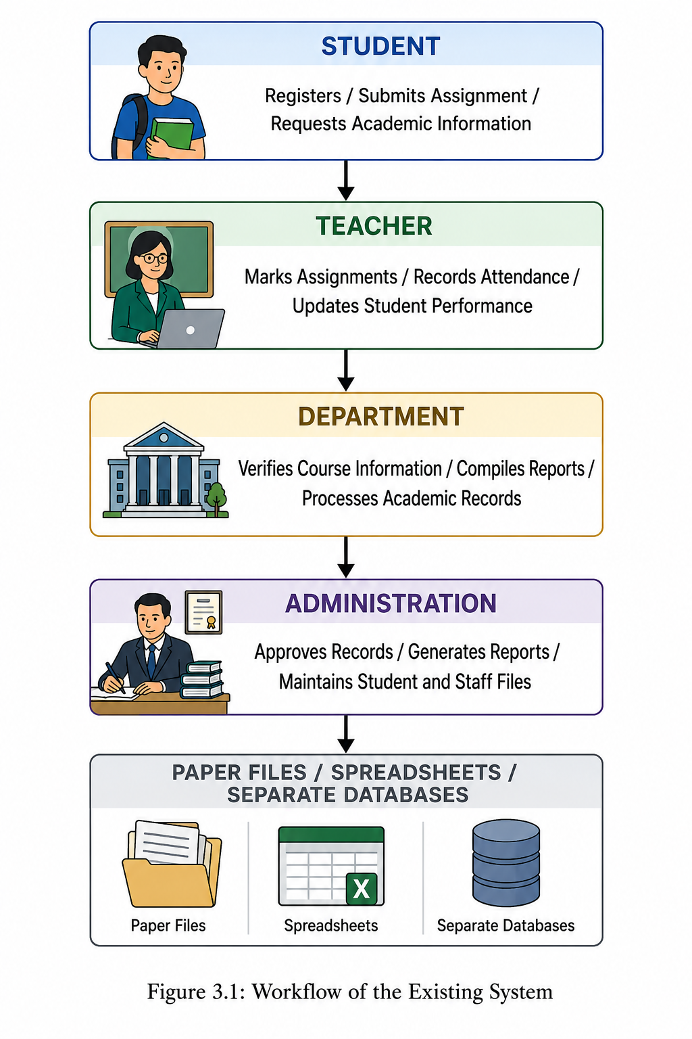

Explanation
The existing workflow begins with students submitting academic requests, assignments, or registration information to their teachers. Teachers manually process these submissions by recording attendance, assessing assignments, and updating students' academic performance. The processed information is subsequently forwarded to the relevant department, where it is verified and consolidated before being sent to the administration for approval and record keeping. Such sequential and manual workflows are common in institutions that rely on traditional academic management practices, often resulting in inefficient coordination and delays in service delivery (Almaiah et al., 2020; Turnbull et al., 2021).
Since most of these activities depend on manual documentation or isolated software applications, information is repeatedly transferred between offices before it is permanently stored. This approach increases processing time, creates opportunities for data duplication and human error, and makes retrieving academic records difficult. Furthermore, communication between administrators, teachers, and students is often delayed because there is no centralized platform for sharing academic information. Studies have shown that fragmented educational systems reduce administrative efficiency, hinder timely access to information, and negatively affect collaboration among stakeholders (Salloum et al., 2019; Bond et al., 2021).
The identified weaknesses of this workflow justify the development of a fully integrated Learning Management System that automates academic processes, centralizes data management, improves communication, and provides authorised users with real-time access to educational information. Such integrated systems have been found to enhance institutional efficiency, improve data accuracy, and support more effective teaching, learning, and academic administration (Turnbull et al., 2021; Almaiah et al., 2020).

3.4 Proposed System Workflow
The proposed School Learning Management System (LMS) introduces a centralized and automated workflow that integrates all major academic and administrative activities into a single web-based platform. Unlike the existing manual system, users interact directly with the system through a secure login interface, where access to features is determined by their assigned roles. The system processes user requests, communicates with the database through the backend API, and provides real-time responses to authorised users.
The workflow is designed to reduce manual intervention, improve communication, enhance data security, and ensure that academic information is available whenever required. Administrators, teachers, and students each access customised dashboards containing only the functions relevant to their responsibilities.
Figure 3.2: Workflow of the Proposed Learning Management System
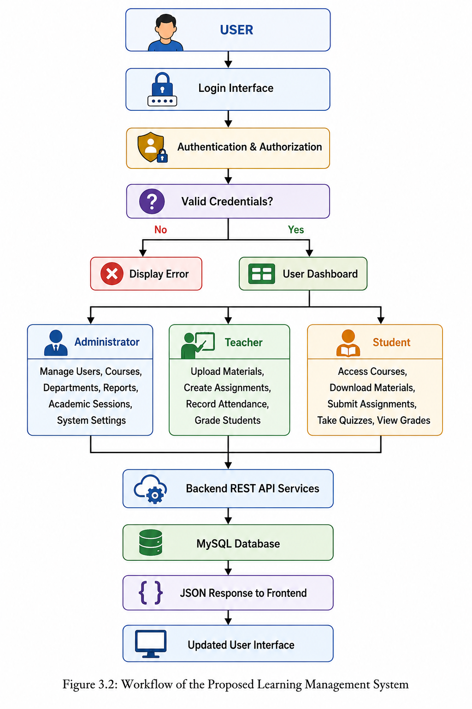
Explanation of the Proposed Workflow
The workflow begins when a user accesses the system through the login page and enters valid authentication credentials. The backend verifies the credentials, checks the user's role, and establishes a secure session. Once authenticated, the user is redirected to a role-specific dashboard.
Administrators are provided with tools for managing users, departments, academic sessions, courses, reports, and other institutional resources. Teachers can create courses, upload learning materials, create assignments and quizzes, record attendance, assess students, and monitor academic performance. Students can access enrolled courses, download learning materials, submit assignments, participate in online assessments, view grades, and receive announcements.
Every action performed by a user is transmitted to the backend through secure RESTful API endpoints. The backend validates the request, performs the necessary business logic, and interacts with the MySQL database using prepared statements to maintain data integrity and security. The API returns responses in JSON format, which are processed by the frontend to update the user interface dynamically without exposing backend implementation details.
Compared to the existing workflow, the proposed system significantly reduces paperwork, eliminates duplication of records, improves communication among stakeholders, enhances data security through authentication and role-based access control, and enables faster retrieval of academic information. The automated workflow also supports real-time processing of academic activities, thereby improving the efficiency and effectiveness of educational administration.

3.5 Functional Requirements
Functional requirements describe the specific operations and services that the proposed School Learning Management System (LMS) must provide to satisfy the needs of its users. The system is designed using role-based access control, ensuring that each category of user has access only to the functions relevant to their responsibilities. The major functional requirements are grouped according to the three primary user roles: Administrator, Teacher, and Student.
3.5.1 Functional Requirements for the Administrator
The administrator is responsible for managing the overall operation of the Learning Management System. The system shall enable the administrator to perform the following functions:
- Securely log into and log out of the system.
- Access an administrative dashboard displaying key system statistics.
- Create, update, deactivate, and manage user accounts.
- Assign user roles and permissions.
- Manage departments and academic programmes.
- Create, update, and manage courses.
- Assign teachers to courses.
- Manage academic years, semesters, and sessions.
- View student enrolment information.
- Generate academic and administrative reports.
- View system audit logs and user activities.
- Configure system settings.
- Perform database backup and recovery operations.
- Manage announcements and institutional notifications.
- Monitor overall system performance and usage.

3.5.2 Functional Requirements for the Teacher
Teachers are responsible for delivering course content and assessing students. The proposed system shall enable teachers to perform the following functions:
- Securely log into and log out of the system.
- Access a personalised teacher dashboard.
- View assigned courses.
- Create and update course information where permitted.
- Upload, edit, archive, and delete learning materials.
- Create assignments with submission deadlines.
- Create and manage online quizzes and examinations.
- Grade assignments and quizzes.
- Record and manage student attendance.
- View enrolled students for each course.
- Publish announcements to students.
- View student submissions.
- Provide feedback on submitted assignments.
- Monitor student academic performance.
- Generate course-related reports.

3.5.3 Functional Requirements for the Student
Students interact with the system primarily to access learning resources and participate in academic activities. The system shall enable students to perform the following functions:
- Securely log into and log out of the system.
- Access a personalised student dashboard.
- View registered or enrolled courses.
- Access and download learning materials.
- Submit assignments electronically.
- Participate in online quizzes and examinations.
- View assignment deadlines.
- Receive announcements and notifications.
- View grades and academic performance.
- Monitor attendance records.
- Update permitted profile information.
- Communicate with instructors through the system where applicable.

3.5.4 General Functional Requirements
In addition to user-specific functions, the system shall provide the following general capabilities:
- Authenticate users before granting system access.
- Enforce role-based access control to protect sensitive information.
- Validate user input before processing requests.
- Store academic information securely in a centralised database.
- Support secure file uploads and downloads.
- Record important system activities through audit logs.
- Generate reports in real time.
- Maintain data integrity through database validation and constraints.
- Support RESTful API communication between the frontend and backend.
- Provide consistent JSON responses for all API requests.
- Automatically manage user sessions and log users out after periods of inactivity.
Summary
The functional requirements define the essential services that the proposed School Learning Management System must provide to support effective academic administration and online learning. By separating system functions according to user roles, the proposed solution ensures that administrators, teachers, and students are provided with appropriate tools and permissions while maintaining the security, integrity, and efficiency of the overall system. These requirements serve as the foundation for the system design and implementation presented in the next chapter.

3.6 Non-Functional Requirements
Non-functional requirements describe the quality attributes and operational characteristics that the proposed School Learning Management System (LMS) must possess to ensure efficient, reliable, secure, and user-friendly operation. Unlike functional requirements, which define what the system should do, non-functional requirements specify how well the system should perform under different conditions.
3.6.1 Performance Requirements
The proposed LMS shall provide efficient and timely processing of user requests to ensure a satisfactory user experience.
The system shall:
- Load web pages within three (3) seconds under normal network conditions.
- Process API requests within two (2) seconds for standard operations.
- Support at least 500 concurrent users without significant degradation in performance.
- Allow users to upload learning materials of up to 100 MB per file.
- Process assignment submissions immediately after upload.
- Generate reports within five (5) seconds for standard datasets.
- Minimise server response time through efficient database queries and caching where applicable.

3.6.2 Security Requirements
Since the system stores confidential academic information, appropriate security mechanisms shall be implemented to protect user data and system resources.
The system shall:
- Encrypt user passwords using the bcrypt hashing algorithm.
- Implement Role-Based Access Control (RBAC) to restrict access based on user roles.
- Validate and sanitise all user inputs to prevent malicious attacks.
- Use prepared SQL statements to prevent SQL injection.
- Protect against Cross-Site Scripting (XSS) attacks through input validation and output encoding.
- Incorporate Cross-Site Request Forgery (CSRF) protection for state-changing requests through the use of security tokens where applicable to the authentication and session architecture.
- Automatically terminate inactive user sessions after a predefined timeout period.
- Record login attempts and critical user activities in audit logs.
- Support secure communication using HTTPS when deployed to a production environment.
- Restrict file uploads to approved file types and sizes.

3.6.3 Reliability Requirements
The system shall operate consistently and maintain data integrity during normal operation and unexpected failures.
The system shall:
- Maintain a minimum availability of 99% uptime during normal operation.
- Automatically back up the database at scheduled intervals.
- Maintain transaction integrity during database operations.
- Recover quickly from unexpected system failures.
- Log application errors for troubleshooting and maintenance.
- Prevent data corruption through proper database constraints and validation.
- Ensure uploaded files remain accessible unless intentionally removed by authorised users.

3.6.4 Usability Requirements
The system shall provide an intuitive and user-friendly interface that supports users with varying levels of computer literacy.
The system shall:
- Provide a responsive interface that functions correctly on desktops, tablets, and smartphones.
- Maintain consistent navigation throughout all system pages.
- Display clear labels, icons, and instructions for all major functions.
- Present informative validation and error messages.
- Minimise the number of steps required to complete common tasks.
- Support accessibility features such as readable fonts, sufficient colour contrast, and keyboard navigation where applicable.
- Provide dashboards customised to the responsibilities of administrators, teachers, and students.

3.6.5 Maintainability Requirements
The proposed LMS shall be designed to simplify future maintenance, upgrades, and feature enhancements.
The system shall:
- Follow a modular software architecture.
- Separate the frontend from the backend through RESTful APIs.
- Use reusable components to reduce code duplication.
- Maintain clear documentation for APIs, database structures, and source code.
- Record application logs to facilitate debugging.
- Support future integration with mobile applications and third-party educational services.

3.6.6 Scalability Requirements
The system shall support future institutional growth without requiring significant architectural changes.
The system shall:
- Allow additional users, departments, and courses to be added without affecting system performance.
- Support expansion to multiple campuses or educational institutions.
- Accommodate increasing numbers of uploaded learning materials and assignments.
- Allow additional functional modules, such as online payments, virtual classrooms, and library management, to be integrated in future versions.

3.6.7 Compatibility Requirements
The LMS shall operate consistently across commonly used hardware and software platforms.
The system shall:
- Support modern web browsers including Google Chrome, Microsoft Edge, Mozilla Firefox, and Safari.
- Operate on Windows, Linux, macOS, and Android devices through a web browser.
- Integrate with MySQL database servers.
- Support RESTful API communication using JSON data exchange.

3.6.8 Availability Requirements
The system shall be accessible whenever authorised users require its services.
The system shall:
- Be available 24 hours a day and 7 days a week, except during scheduled maintenance.
- Notify users in advance of planned maintenance activities.
- Resume normal operation promptly after maintenance or unexpected outages.

3.6.9 Context Diagram
Figure 3.3: Context Diagram of the Proposed LMS
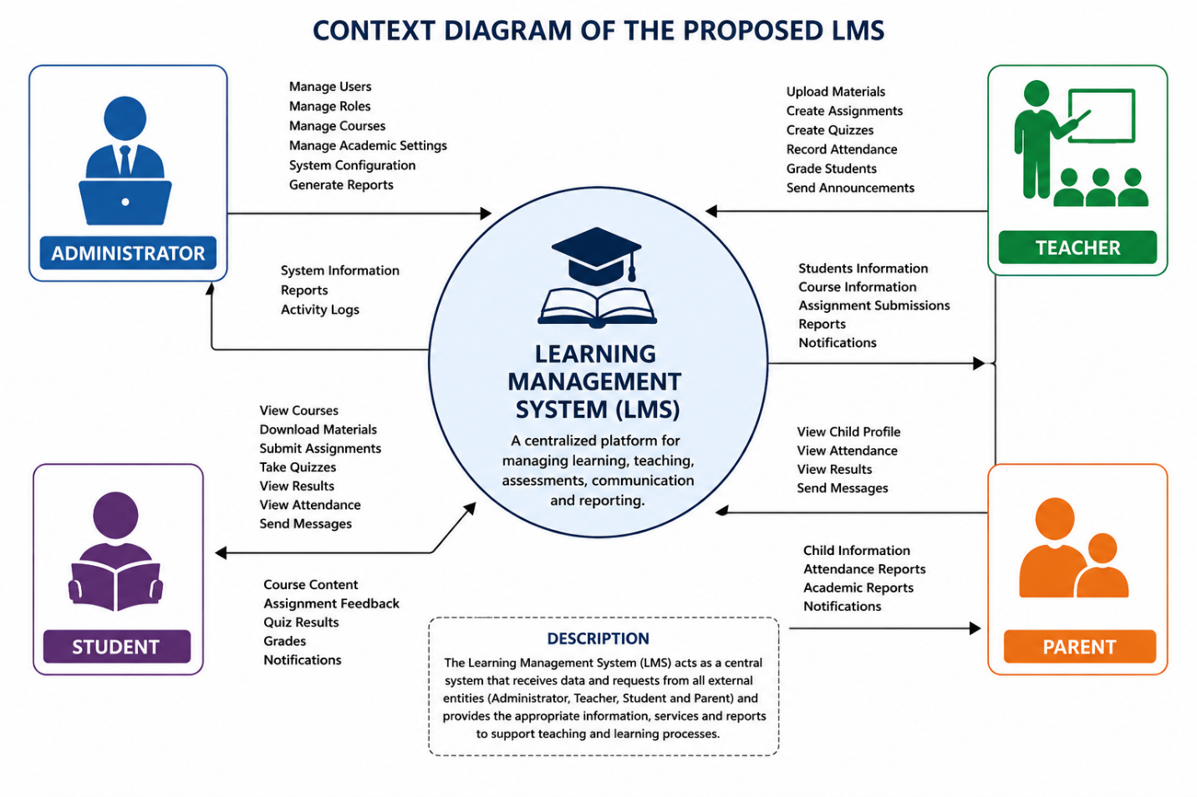
Explanation
The Context Diagram illustrates the interaction between external entities and the Learning Management System. Administrators manage users, courses, and reports. Teachers upload learning materials, create assignments, and record grades. Students access learning resources, submit assignments, and view academic results. The LMS acts as the central processing system that facilitates these interactions.

3.6.10 Data Flow Diagram (Level 0)
Figure 3.4: Data Flow Diagram (DFD Level 0)
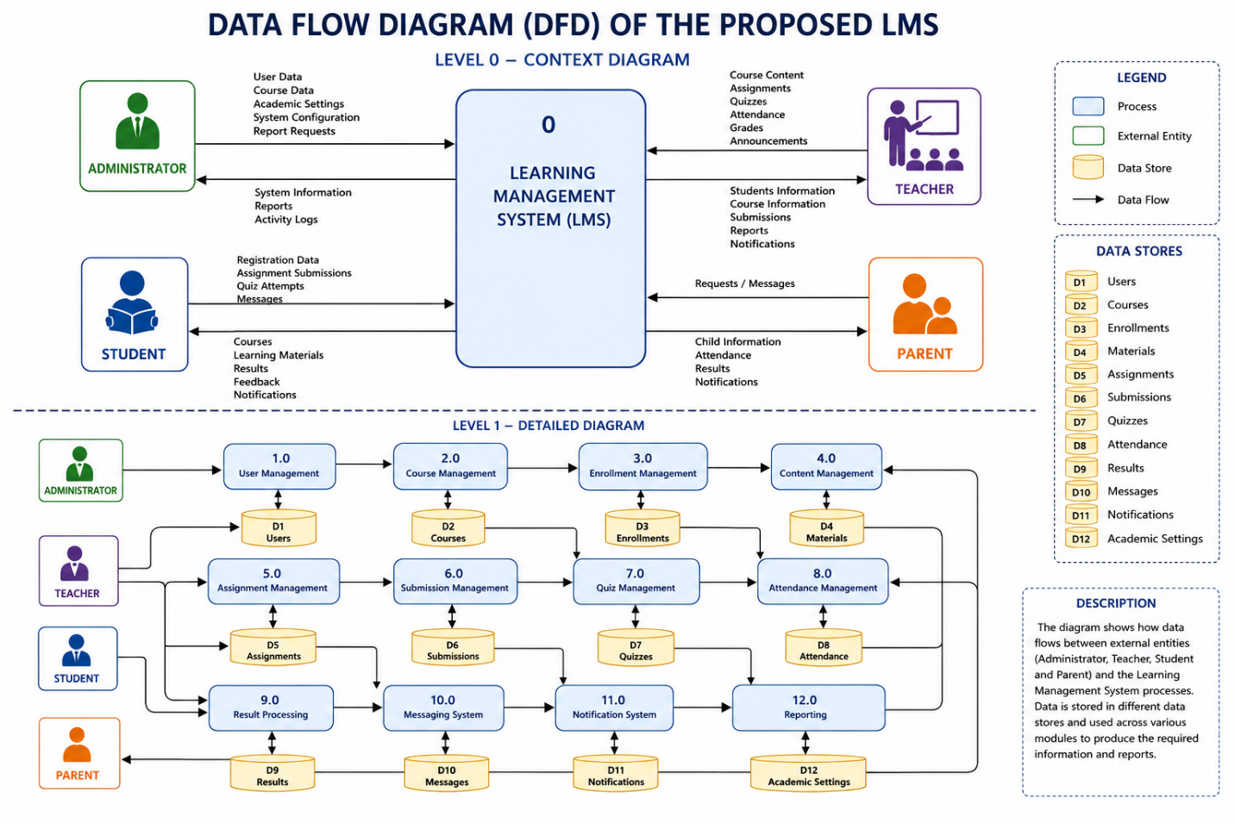
Explanation
The Data Flow Diagram illustrates how information flows within the proposed system. Administrators manage users and courses, teachers upload learning materials and assessments, and students access educational resources and submit assignments. All transactions are stored and retrieved from the LMS database.

3.6.11 Use Case Diagram
Figure 3.5: Use Case Diagram of the Proposed LMS
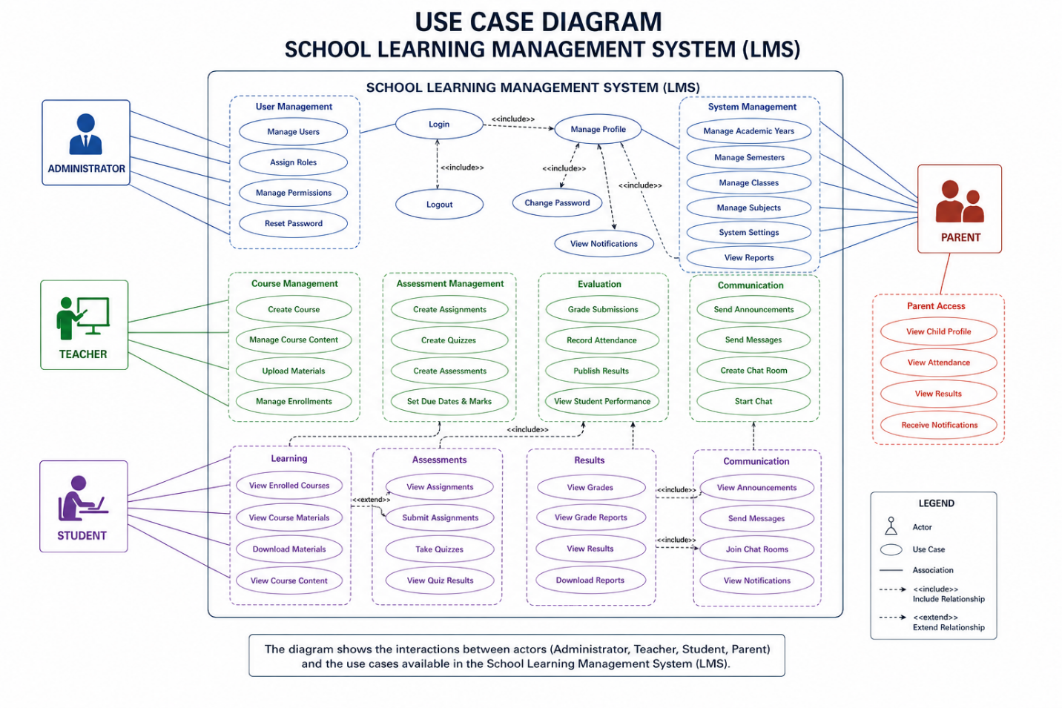
Explanation
The Use Case Diagram identifies the major interactions between users and the system. Administrators perform management and reporting functions, teachers manage academic activities, and students access learning resources and monitor their academic progress.

Summary
The non-functional requirements establish the quality standards that the proposed School Learning Management System must satisfy to operate effectively. These requirements address critical aspects such as performance, security, reliability, usability, maintainability, scalability, compatibility, and availability. Collectively, they ensure that the system not only performs its intended functions but also delivers a secure, efficient, reliable, and user-friendly platform capable of supporting the academic and administrative activities of the institution while accommodating future growth and technological advancements.

3.7 System Requirements
The successful implementation of the proposed School Learning Management System (LMS) depends on the availability of appropriate hardware and software resources. These requirements ensure that the system operates efficiently, securely, and reliably while supporting multiple users simultaneously. The requirements are categorised into hardware requirements and software requirements.

3.7.1 Hardware Requirements
The hardware requirements specify the minimum and recommended computing resources needed to host and access the proposed LMS.
Server Hardware Requirements
The server hosts the backend application, RESTful APIs, database, and uploaded learning resources. To ensure efficient system performance, the following minimum hardware specifications are recommended.
Component | Minimum Requirement | Recommended Requirement
Processor | Intel Core i5 (8th Generation) or AMD Ryzen 5 | Intel Core i7 or AMD Ryzen 7
Memory (RAM) | 8 GB | 16 GB or higher
Storage | 100 GB SSD | 500 GB SSD
Network | Broadband Internet Connection | High-speed Fibre Internet
Backup Storage | External Hard Drive | Cloud Backup Service
Power Supply | UPS | UPS with Generator Backup

Client Hardware Requirements
Client computers are used by administrators, teachers, and students to access the LMS through a web browser.
Component | Minimum Requirement
Processor | Dual-Core Processor (2.0 GHz or higher)
Memory (RAM) | 4 GB or higher
Storage | 20 GB Free Disk Space
Display | 1366 × 768 Resolution or Higher
Internet Connection | Stable Broadband Connection
Input Devices | Keyboard and Mouse or Touchscreen

3.7.2 Software Requirements
The software requirements describe the applications, operating systems, databases, and development tools required for developing, deploying, and operating the proposed system.
Server Software Requirements
Software | Version / Requirement
Operating System | Windows 10/11, Ubuntu Linux, Windows Server 2019/2022/2025 or another compatible Linux distribution
Web Server | Apache HTTP Server
Programming Language | PHP 8.x
Database Management System | MySQL 8.x
API Format | RESTful API using JSON
Local Development Environment | XAMPP
Database Administration | phpMyAdmin

Client Software Requirements
Users access the LMS using a standard web browser without installing additional software.
Software | Requirement
Web Browser | Google Chrome (latest version)
Web Browser | Microsoft Edge (latest version)
Web Browser | Mozilla Firefox (latest version)
Web Browser | Safari (latest version for macOS users)
Internet Connection | Stable Internet Access

Development Software Requirements
The system was developed using modern software engineering tools that support version control, API development, debugging, and collaborative development.
Software | Purpose
Visual Studio Code | Source code development
Git | Version control
GitHub | Source code repository and collaboration
Postman | API testing and documentation
XAMPP | Local web server and database environment
phpMyAdmin | Database administration
Composer | PHP dependency management
Google Chrome Developer Tools | Frontend debugging and API inspection

3.7.3 Network Requirements
The Learning Management System is designed as a web-based application; therefore, reliable network connectivity is essential for both server and client operations.
The system requires:
- A stable broadband Internet connection.
- Secure communication using the HTTP/HTTPS protocol.
- Local Area Network (LAN) or Wireless LAN (WLAN) support within the institution.
- Continuous network availability to ensure uninterrupted access to learning resources and academic services.

3.7.4 Browser Compatibility
To ensure accessibility across different computing platforms, the proposed LMS is compatible with modern web browsers, including:
- Google Chrome
- Microsoft Edge
- Mozilla Firefox
- Safari
- Opera
The user interface is responsive and adapts automatically to desktops, laptops, tablets, and smartphones, providing a consistent user experience across different screen sizes.

3.7.5 Summary
The proposed School Learning Management System requires modest hardware resources and widely available software technologies, making it suitable for deployment in educational institutions of varying sizes. The use of PHP, MySQL, Apache, RESTful APIs, and modern web browsers ensures compatibility, portability, and ease of maintenance. Furthermore, the adoption of development tools such as Visual Studio Code, Git, GitHub, and Postman supports efficient software development, testing, and future system enhancement. These requirements provide the technical foundation necessary for the successful implementation and long-term operation of the proposed Learning Management System.

3.8 Database Requirements
The database is one of the most important components of the proposed School Learning Management System (LMS). It serves as the central repository for storing, organising, and managing all academic and administrative information generated by the system. The database maintains records relating to users, courses, departments, enrolments, learning materials, assignments, grades, attendance, announcements, and other institutional data. A well-designed database ensures data consistency, efficient retrieval of information, and secure management of academic records.

3.8.1 Database Management System Selection
The proposed Learning Management System uses MySQL as its Database Management System (DBMS). MySQL was selected because it is an open-source, reliable, and high-performance relational database management system that integrates effectively with PHP and supports web-based application development.
The selection of MySQL was based on the following advantages:
- It is open-source and freely available, making it cost-effective for educational institutions.
- It provides high-speed data processing and efficient query execution.
- It integrates seamlessly with PHP and Apache through the XAMPP development environment.
- It supports relational database structures suitable for complex academic information.
- It offers strong security features such as user authentication and access privileges.
- It supports backup, recovery, and transaction management.
- It is widely adopted in educational and enterprise web applications, ensuring long-term community support and documentation.

3.8.2 Database Normalisation
Database normalisation is the process of organising data into related tables to minimise redundancy and improve data integrity. The database for the proposed LMS was designed following the principles of relational database normalisation.
The database satisfies the following normal forms:
First Normal Form (1NF)
The database ensures that:
- Each table contains atomic (indivisible) values.
- Every record is uniquely identified by a primary key.
- Repeating groups of data have been eliminated.
Second Normal Form (2NF)
The database satisfies Second Normal Form by ensuring that:
- All non-key attributes depend entirely on the primary key.
- Partial dependencies have been removed.
- Related information is stored in separate tables.
Third Normal Form (3NF)
The database satisfies Third Normal Form by ensuring that:
- There are no transitive dependencies.
- Every non-key attribute depends only on the primary key.
- Data duplication is minimised.
- Data consistency is maintained throughout the database.
The application of these normalisation principles improves storage efficiency, simplifies maintenance, and reduces the possibility of update anomalies.

3.8.3 Database Relationships
The proposed database follows a relational model in which related tables are connected using primary keys and foreign keys. These relationships maintain referential integrity and ensure consistency among the various academic records.
Some of the major relationships in the database include:
Parent Table | Child Table | Relationship
Roles | Users | One-to-Many
Departments | Courses | One-to-Many
Users (Teacher) | Courses | One-to-Many
Courses | Materials | One-to-Many
Courses | Assignments | One-to-Many
Courses | Quizzes | One-to-Many
Courses | Attendance | One-to-Many
Students | Enrolments | One-to-Many
Courses | Enrolments | One-to-Many
Assignments | Submissions | One-to-Many
Students | Submissions | One-to-Many
Students | Grades | One-to-Many
Courses | Grades | One-to-Many
Users | Audit Logs | One-to-Many

These relationships enable the system to retrieve related academic information efficiently while maintaining data accuracy and consistency.

3.8.4 Database Security
Since the database stores confidential institutional information, several security mechanisms have been incorporated to protect data from unauthorised access and malicious activities.
The proposed system implements the following database security measures:
- User authentication before accessing protected resources.
- Role-Based Access Control (RBAC) to restrict database operations according to user responsibilities.
- Password encryption using the bcrypt hashing algorithm.
- Prepared SQL statements to prevent SQL injection attacks.
- Input validation and sanitisation before database operations.
- Foreign key constraints to preserve referential integrity.
- Database transaction management to maintain consistency during updates.
- Automatic recording of important activities in audit logs.
- Scheduled database backups to minimise data loss.
- Recovery procedures for restoring data in the event of system failure.
- Restricted administrative privileges to authorised personnel only.
These measures help ensure the confidentiality, integrity, and availability of academic information stored within the database.

3.8.5 Database Entities
The proposed Learning Management System database consists of several interconnected entities that support the various academic and administrative functions of the system. The major entities include:
- Users
- Roles
- Departments
- Courses
- Student Enrolments
- Learning Materials
- Assignments
- Assignment Submissions
- Quizzes
- Quiz Attempts
- Grades
- Attendance Records
- Announcements
- Academic Sessions
- Audit Logs
Each entity represents a specific aspect of the educational process and is linked to other entities through well-defined relationships.

3.8.6 Database Design Considerations
The database was designed with the following objectives:
- Eliminate unnecessary data redundancy.
- Ensure high data integrity through relational constraints.
- Support efficient searching, sorting, and reporting.
- Provide scalability for future institutional growth.
- Facilitate secure storage of academic records.
- Support RESTful API operations through efficient query execution.
- Enable easy maintenance and future database expansion.

Summary
The proposed School Learning Management System employs MySQL, a robust relational database management system, to provide efficient and secure storage of academic and administrative information. The database has been normalised up to the Third Normal Form (3NF) to minimise redundancy and improve consistency. Relationships among entities are maintained using primary and foreign keys, while comprehensive security mechanisms—including authentication, role-based access control, prepared statements, password hashing, and scheduled backups—protect sensitive institutional data. Consequently, the database provides a reliable and scalable foundation for supporting the functional requirements of the proposed Learning Management System.

3.9 API Architecture
The proposed School Learning Management System (LMS) adopts an API-first architecture, in which the frontend and backend are developed as separate components that communicate through Representational State Transfer (REST) APIs. This architectural approach promotes modularity, scalability, maintainability, and reusability by ensuring that the user interface is independent of the application logic and database operations.
In the proposed architecture, users interact with the system through a web-based frontend developed using HTML5, CSS3, and JavaScript. The frontend sends requests to the backend through RESTful API endpoints using standard HTTP methods. The backend, developed with PHP, processes these requests, performs authentication and business logic, communicates with the MySQL database, and returns responses in JavaScript Object Notation (JSON) format.
This separation of concerns enables the backend APIs to serve multiple client applications, including web, mobile, and desktop applications, without modifying the underlying business logic.

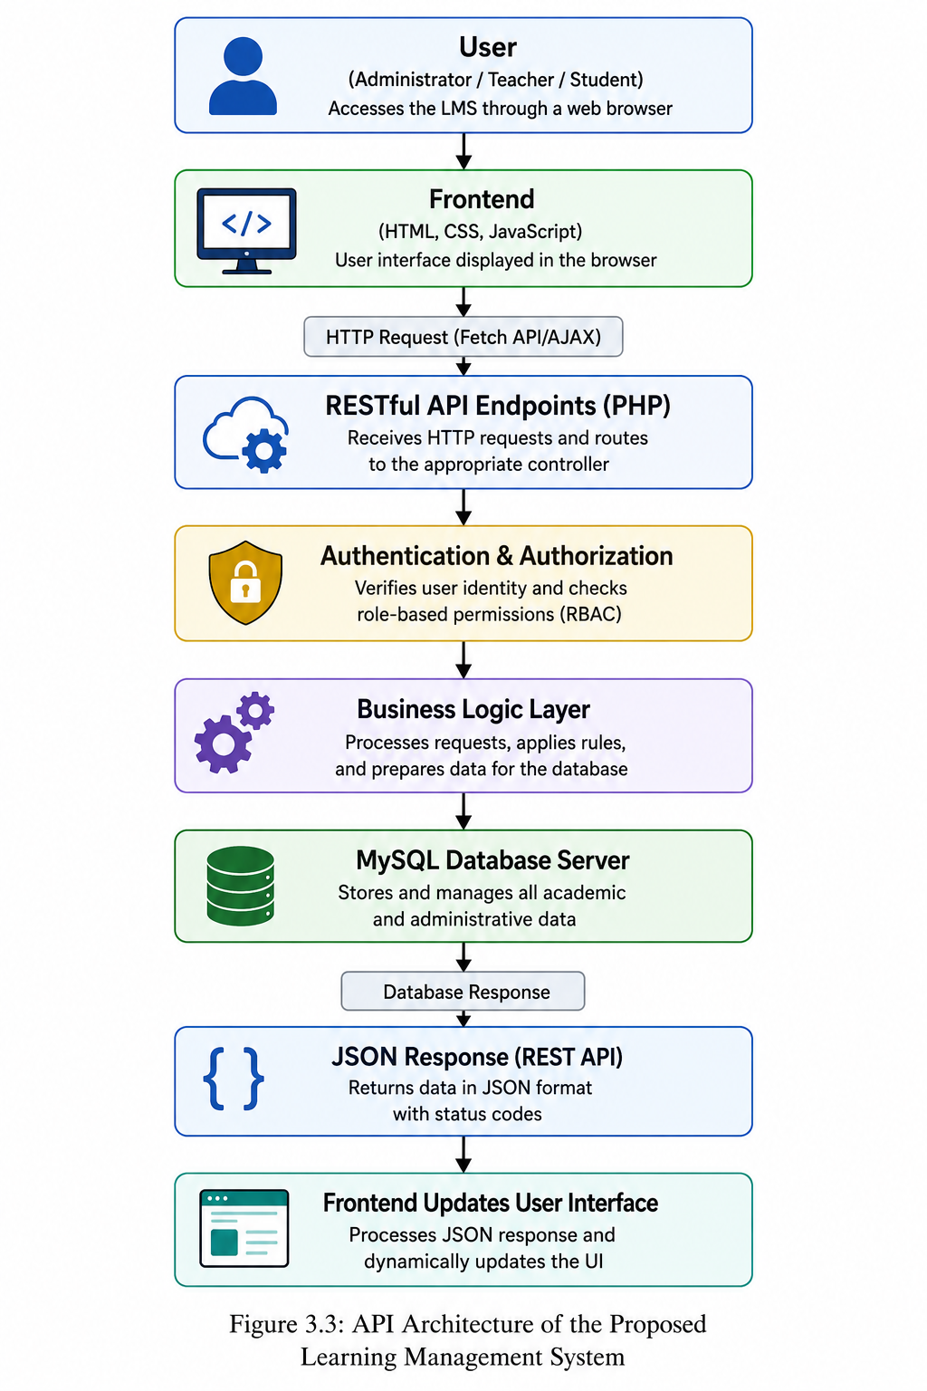
aFigure 3.6: API Architecture of the Proposed Learning Management System

3.9.1 RESTful API Design
The proposed LMS follows the principles of Representational State Transfer (REST). REST is an architectural style for designing web services that enables communication between distributed software components using standard HTTP protocols.
Each resource within the system, such as users, courses, assignments, learning materials, attendance records, and grades, is represented by a unique API endpoint. These endpoints perform specific operations without exposing the internal implementation of the application.
Examples of API resources include:
- /api/auth/login
- /api/users
- /api/courses
- /api/materials
- /api/assignments
- /api/quizzes
- /api/grades
- /api/attendance
This resource-oriented approach simplifies integration, maintenance, and future system expansion.

3.9.2 HTTP Methods
The RESTful API uses standard HTTP methods to perform different operations on system resources.
HTTP Method | Purpose | Example
GET | Retrieve information | Retrieve course materials
POST | Create new resources | Create a course or upload material
PUT | Update existing resources | Update course details or grades
DELETE | Remove resources | Delete a course or learning material

Using standard HTTP methods improves consistency and makes the API easier to understand and integrate with different client applications.

3.9.3 JSON Data Exchange
The proposed system uses JavaScript Object Notation (JSON) as the standard data exchange format between the frontend and backend.
When a user performs an operation, the frontend sends data to the backend as a JSON request. After processing the request, the backend returns a JSON response containing the requested information or an appropriate error message.
A typical API response includes:
- Operation status
- Response message
- Requested data
- HTTP status code
- Timestamp
JSON was selected because it is lightweight, easy to read, language-independent, and supported by modern web browsers and programming languages.

3.9.4 Stateless Communication
The RESTful APIs are designed using the principle of stateless communication. Under this approach, every client request contains all the information required for the server to process that request. The server does not rely on previous requests to determine the current request's context.
The benefits of stateless communication include:
- Improved scalability.
- Reduced server memory usage.
- Easier load balancing.
- Better fault tolerance.
- Simplified API maintenance.
Although user authentication is managed through secure sessions, each API request is independently validated before processing to ensure that only authorised users can access protected resources.

3.9.5 Authentication and Authorization
Before granting access to protected resources, every API request passes through an authentication and authorisation layer.
The authentication component verifies the user's identity using secure login credentials and establishes a valid user session. Once authenticated, the authorisation component determines whether the user has sufficient privileges to perform the requested operation based on Role-Based Access Control (RBAC).
The system defines three primary user roles:
- Administrator
- Teacher
- Student
Each role is granted access only to the resources and operations relevant to its responsibilities, thereby enhancing system security and protecting confidential academic information.

3.9.6 Advantages of the API-First Architecture
The API-first approach provides several advantages over traditional monolithic web applications in which the frontend and backend are tightly coupled.
The proposed architecture offers the following benefits:
- Clear separation between the frontend and backend.
- Improved maintainability through modular development.
- Easier testing of backend services using tools such as Postman.
- Reusability of APIs across web, mobile, and desktop applications.
- Simplified integration with third-party educational systems.
- Improved scalability through independent deployment of frontend and backend components.
- Faster development by allowing frontend and backend teams to work independently.
- Consistent communication through standard JSON responses.

Summary
The proposed School Learning Management System adopts an API-first architecture that separates the presentation layer from the business logic and database layers. Communication between the frontend and backend is achieved through RESTful APIs, HTTP methods, and JSON data exchange, while stateless request processing improves scalability and maintainability. Authentication and role-based authorisation ensure that only authorised users can access protected resources. This architecture provides a secure, flexible, and scalable foundation capable of supporting future enhancements, including mobile applications and integration with external educational platforms.

3.10 Module Description
The proposed School Learning Management System (LMS) is organised into several functional modules, each responsible for performing a specific set of academic or administrative tasks. This modular design improves maintainability, scalability, and system organisation by separating related functionalities into independent components. Each module communicates with the backend through RESTful APIs and interacts with the MySQL database to perform authorised operations.

3.10.1 Authentication Module
The Authentication Module is responsible for verifying user identities before granting access to the system. It ensures that only authorised users can access protected resources while maintaining secure user sessions.
Functions
- User login
- User logout
- Session management
- Password verification
- Role-Based Access Control (RBAC)
- User authentication
- Session timeout management
- Password encryption using bcrypt

3.10.2 User Management Module
This module enables administrators to manage users within the system. It maintains records for administrators, teachers, and students while controlling user roles and permissions.
Functions
- Create user accounts
- Update user information
- Delete or deactivate users
- Assign user roles
- Manage departments
- Reset passwords
- Search and filter users
- View user activity

3.10.3 Course Management Module
The Course Management Module manages all academic courses offered by the institution. It allows administrators and authorised teachers to create and organise courses while assigning instructors and enrolling students.
Functions
- Create courses
- Edit course information
- Delete or archive courses
- Assign teachers to courses
- Manage course enrolments
- View course details
- Search available courses
- Organise courses by department and academic session

3.10.4 Learning Materials Module
This module manages digital learning resources uploaded by teachers. Students can access and download materials for their enrolled courses.
Functions
- Upload learning materials
- Download learning materials
- Archive or restore materials
- Delete learning materials
- Organise materials by course
- Search learning resources
- Preview supported files
- Manage uploaded documents

3.10.5 Assignment Management Module
The Assignment Management Module enables teachers to create coursework while allowing students to submit assignments electronically.
Functions
- Create assignments
- Edit assignment details
- Set submission deadlines
- Upload assignment instructions
- Submit assignments
- View student submissions
- Grade assignments
- Provide feedback
- Monitor submission status

3.10.6 Quiz and Assessment Module
This module supports online quizzes and assessments that evaluate students' understanding of course content.
Functions
- Create quizzes
- Add objective and subjective questions
- Configure quiz duration
- Schedule quizzes
- Submit quiz attempts
- Automatically score objective questions
- Record quiz results
- Generate assessment reports

3.10.7 Attendance Management Module
The Attendance Module enables teachers to record and monitor student attendance for each course.
Functions
- Record attendance
- Update attendance records
- View attendance history
- Generate attendance reports
- Monitor absenteeism
- Export attendance records

3.10.8 Grade Management Module
The Grade Management Module manages student assessment results and overall academic performance.
Functions
- Record grades
- Update grades
- Calculate final scores
- Generate grade reports
- View student performance
- Export academic results

3.10.9 Announcement and Notification Module
This module facilitates communication between administrators, teachers, and students by distributing academic announcements and notifications.
Functions
- Publish announcements
- Send notifications
- Display important notices
- Notify assignment deadlines
- Notify quiz schedules
- Notify grade publication
- Broadcast institutional messages

3.10.10 Reporting Module
The Reporting Module provides administrators and teachers with analytical reports that support academic planning and decision-making.
Functions
- Generate student reports
- Generate course reports
- Generate attendance reports
- Generate grade reports
- Produce enrolment statistics
- Export reports in printable formats
- Monitor overall academic performance

3.10.11 Audit and Activity Logging Module
The Audit Module records significant user activities performed within the system. These records improve accountability, troubleshooting, and system security.
Functions
- Record login activities
- Record user operations
- Monitor system access
- Record administrative actions
- Track failed login attempts
- Generate audit reports

3.10.12 API Integration Module
The API Integration Module serves as the communication layer between the frontend application and the backend services. It processes requests, validates data, and returns JSON responses.
Functions
- Process RESTful API requests
- Validate incoming requests
- Return JSON responses
- Handle HTTP methods (GET, POST, PUT, DELETE)
- Communicate with the database
- Handle API errors
- Manage data exchange between frontend and backend

3.10.13 Database Management Module
This module manages all database operations performed by the system and ensures that academic information is stored securely and consistently.
Functions
- Store system data
- Retrieve records
- Update information
- Delete records
- Manage database relationships
- Maintain referential integrity
- Perform database backup and recovery
- Optimise database performance

Summary
The proposed School Learning Management System is organised into specialised modules that collectively support academic administration, teaching, and learning. The Authentication, User Management, Course Management, Learning Materials, Assignment, Quiz, Attendance, Grade, Announcement, Reporting, Audit, API Integration, and Database Management modules work together to provide a secure, scalable, and efficient platform. This modular architecture simplifies system maintenance, enhances scalability, promotes code reusability, and allows future expansion without significantly affecting existing functionality.

3.11 Data Dictionary
The data dictionary provides a description of the major data elements used in the proposed School Learning Management System (LMS). It defines the attributes, data types, and purposes of important fields within the database. The data dictionary serves as a reference for developers, database administrators, and system users by promoting consistency in database design and implementation.

3.11.1 Users Table
Field | Data Type | Description
user_id | INT | Unique identifier for each user
role_id | INT | References the user's role
department_id | INT | References the department
username | VARCHAR(50) | Username for login
email | VARCHAR(100) | User email address
password | VARCHAR(255) | Encrypted password
first_name | VARCHAR(100) | User's first name
last_name | VARCHAR(100) | User's last name
phone | VARCHAR(20) | Contact number
status | ENUM | Account status (Active/Inactive)
created_at | TIMESTAMP | Date account was created

3.11.2 Roles Table
Field | Data Type | Description
role_id | INT | Unique role identifier
role_name | VARCHAR(50) | Name of the role
description | TEXT | Role description

3.11.3 Departments Table
Field | Data Type | Description
department_id | INT | Unique department identifier
department_name | VARCHAR(100) | Department name
department_code | VARCHAR(20) | Department code
description | TEXT | Department description

3.11.4 Courses Table
Field | Data Type | Description
course_id | INT | Unique course identifier
department_id | INT | Department offering the course
teacher_id | INT | Assigned teacher
course_code | VARCHAR(20) | Course code
course_name | VARCHAR(150) | Course title
description | TEXT | Course description
credit_hours | INT | Credit hours
semester | VARCHAR(20) | Academic semester
academic_year | VARCHAR(20) | Academic year
status | ENUM | Course status

3.11.5 Student Enrolments Table
Field | Data Type | Description
enrolment_id | INT | Enrolment identifier
student_id | INT | Registered student
course_id | INT | Enrolled course
enrolment_date | DATE | Date of enrolment
status | ENUM | Enrolment status

3.11.6 Learning Materials Table
Field | Data Type | Description
material_id | INT | Material identifier
course_id | INT | Associated course
teacher_id | INT | Uploading teacher
title | VARCHAR(200) | Material title
material_type | VARCHAR(50) | Material category
file_path | VARCHAR(255) | Storage location
file_size | BIGINT | File size
upload_date | DATETIME | Upload date
is_archived | BOOLEAN | Archive status

3.11.7 Assignments Table
Field | Data Type | Description
assignment_id | INT | Assignment identifier
course_id | INT | Related course
teacher_id | INT | Assignment creator
title | VARCHAR(200) | Assignment title
description | TEXT | Assignment details
due_date | DATETIME | Submission deadline
total_marks | DECIMAL(5,2) | Maximum marks
created_at | TIMESTAMP | Date created

3.11.8 Assignment Submissions Table
Field | Data Type | Description
submission_id | INT | Submission identifier
assignment_id | INT | Related assignment
student_id | INT | Student submitting
file_path | VARCHAR(255) | Submitted file
submission_date | DATETIME | Submission date
marks | DECIMAL(5,2) | Marks awarded
feedback | TEXT | Teacher comments
status | ENUM | Submission status

3.11.9 Quizzes Table
Field | Data Type | Description
quiz_id | INT | Quiz identifier
course_id | INT | Associated course
teacher_id | INT | Quiz creator
title | VARCHAR(200) | Quiz title
duration | INT | Time limit (minutes)
total_marks | DECIMAL(5,2) | Total marks
availability_date | DATETIME | Quiz opening date

3.11.10 Grades Table
Field | Data Type | Description
grade_id | INT | Grade identifier
student_id | INT | Student receiving grade
course_id | INT | Course
assessment_type | VARCHAR(50) | Assignment, Quiz, Exam
score | DECIMAL(5,2) | Marks obtained
grade | VARCHAR(5) | Letter grade
remarks | VARCHAR(100) | Performance remarks

3.11.11 Attendance Table
Field | Data Type | Description
attendance_id | INT | Attendance identifier
student_id | INT | Student
course_id | INT | Course
attendance_date | DATE | Attendance date
status | ENUM | Present, Absent, Late
remarks | VARCHAR(100) | Attendance remarks

3.11.12 Announcements Table
Field | Data Type | Description
announcement_id | INT | Announcement identifier
user_id | INT | Publisher
title | VARCHAR(200) | Announcement title
content | TEXT | Announcement details
publish_date | DATETIME | Publication date
expiry_date | DATETIME | Expiry date

3.11.13 Audit Logs Table
Field | Data Type | Description
log_id | INT | Log identifier
user_id | INT | User performing activity
action | VARCHAR(150) | Performed action
module | VARCHAR(100) | System module
ip_address | VARCHAR(50) | Client IP address
created_at | DATETIME | Activity timestamp

Summary
The data dictionary defines the major entities and attributes used in the proposed School Learning Management System database. It establishes a common reference for developers and database administrators, ensuring consistency in naming conventions, data types, and relationships. The documented fields support secure storage, efficient retrieval, and accurate management of academic and administrative information while providing a foundation for system implementation and future maintenance.

3.12 Decision Table
The proposed School Learning Management System implements Role-Based Access Control (RBAC) to ensure that users can only perform functions authorised for their respective roles. The decision table below summarises the permissions assigned to Administrators, Teachers, and Students.
Table 3.14: Decision Table for User Roles and Permissions
System Function | Administrator | Teacher | Student
Login | ✓ | ✓ | ✓
Logout | ✓ | ✓ | ✓
View Dashboard | ✓ | ✓ | ✓
Manage User Accounts | ✓ | ✗ | ✗
Manage Roles & Permissions | ✓ | ✗ | ✗
Manage Departments | ✓ | ✗ | ✗
Create Courses | ✓ | ✓* | ✗
Edit Courses | ✓ | ✓* | ✗
Delete Courses | ✓ | ✗ | ✗
View Courses | ✓ | ✓ | ✓
Enrol Students | ✓ | ✗ | ✓**
Upload Learning Materials | ✗ | ✓ | ✗
Download Learning Materials | ✓ | ✓ | ✓
Archive Learning Materials | ✗ | ✓ | ✗
Create Assignments | ✗ | ✓ | ✗
Submit Assignments | ✗ | ✗ | ✓
Grade Assignments | ✗ | ✓ | ✗
Create Quizzes | ✗ | ✓ | ✗
Attempt Quizzes | ✗ | ✗ | ✓
Record Attendance | ✗ | ✓ | ✗
View Attendance | ✓ | ✓ | ✓
Publish Announcements | ✓ | ✓ | ✗
View Announcements | ✓ | ✓ | ✓
View Grades | ✓ | ✓ | ✓***
Generate Reports | ✓ | ✓**** | ✗
View Audit Logs | ✓ | ✗ | ✗
Backup Database | ✓ | ✗ | ✗
Manage System Settings | ✓ | ✗ | ✗

Key
- ✓ = Permission Granted
- ✗ = Permission Denied
- ✓* = Teachers can create and manage only the courses assigned to them.
- ✓** = Teachers can generate reports only for their own courses.
- ✓ = Students can enrol only in courses made available to them (subject to institutional policy).
- ✓* = Students can view only their own grades and academic records.

Explanation
The decision table illustrates how the proposed Learning Management System enforces access control through Role-Based Access Control (RBAC). Administrators possess full privileges to manage users, departments, courses, reports, audit logs, and system configuration. Teachers are responsible for instructional activities such as managing assigned courses, uploading learning materials, creating assignments and quizzes, recording attendance, grading student work, and publishing announcements. Students have limited access, allowing them to view course information, access learning materials, submit assignments, participate in quizzes, monitor attendance, and view their individual academic results.
By restricting users to only the functions necessary for their responsibilities, the system enhances security, protects sensitive academic information, and maintains the integrity of institutional data.

3.13 Use Case Description
The Use Case Description explains the major interactions between the users of the proposed School Learning Management System (LMS) and the system itself. Each use case represents a specific function performed by an actor to achieve a particular objective. The system has three primary actors: Administrator, Teacher, and Student, each interacting with the system according to their assigned roles and privileges.
Table 3.15: Use Case Description
Use Case | Primary Actor | Description
Login | Administrator, Teacher, Student | Authenticates users before granting access to the system.
Logout | Administrator, Teacher, Student | Ends the current user session securely.
View Dashboard | Administrator, Teacher, Student | Displays role-specific information and system activities.
Manage Users | Administrator | Creates, updates, deactivates, and manages user accounts and roles.
Manage Departments | Administrator | Creates, updates, and manages academic departments.
Create Course | Administrator, Teacher | Creates a new course and assigns course information.
Update Course | Administrator, Teacher | Modifies course details and settings.
View Courses | Administrator, Teacher, Student | Displays available courses according to user privileges.
Enrol Student | Administrator | Registers students for selected courses.
Upload Learning Material | Teacher | Uploads lecture notes, presentations, videos, and other learning resources.
Download Learning Material | Teacher, Student | Downloads learning materials from enrolled courses.
Archive Learning Material | Teacher | Archives outdated or inactive learning materials.
Create Assignment | Teacher | Creates assignments for students enrolled in a course.
Submit Assignment | Student | Uploads completed assignments before the submission deadline.
Grade Assignment | Teacher | Evaluates submitted assignments and records marks.
Create Quiz | Teacher | Creates online quizzes for assessment.
Attempt Quiz | Student | Completes quizzes within the allocated time.
Record Attendance | Teacher | Records students' attendance during lectures.
View Attendance | Teacher, Student | Displays attendance records for courses.
Record Grades | Teacher | Records examination and assessment scores.
View Grades | Student, Teacher | Displays student academic performance.
Publish Announcement | Administrator, Teacher | Posts announcements and important academic information.
View Announcements | Administrator, Teacher, Student | Displays institutional and course announcements.
Generate Reports | Administrator, Teacher | Produces reports on academic activities, attendance, grades, and users.
View Audit Logs | Administrator | Reviews user activities and system events for security and monitoring.
Backup Database | Administrator | Performs database backup to prevent data loss.

Description of Major Use Cases
Login
Actor: Administrator, Teacher, Student
Purpose:
To authenticate users and grant secure access to the Learning Management System.
Precondition:
- User account exists.
- Valid username and password are available.
Main Flow:
- User enters login credentials.
- System validates the credentials.
- User is authenticated.
- Appropriate dashboard is displayed.
Postcondition:
- User session is created.
- Access permissions are assigned according to the user's role.

Upload Learning Material
Actor: Teacher
Purpose:
To provide students with lecture notes, presentations, videos, and other educational resources.
Precondition:
- Teacher is logged into the system.
- Teacher is assigned to the selected course.
Main Flow:
- Teacher selects a course.
- Teacher enters material details.
- Teacher uploads the file.
- System validates the file.
- Material is stored in the database and file storage.
- Students can access the uploaded material.
Postcondition:
- Learning material becomes available to authorised students.

Submit Assignment
Actor: Student
Purpose:
To submit completed coursework electronically.
Precondition:
- Student is enrolled in the course.
- Assignment is available and submission deadline has not expired.
Main Flow:
- Student selects an assignment.
- Student uploads the completed work.
- System validates the uploaded file.
- Submission is stored successfully.
- Confirmation message is displayed.
Postcondition:
- Assignment is recorded and becomes available for grading.

Grade Assignment
Actor: Teacher
Purpose:
To evaluate submitted assignments and provide marks and feedback.
Precondition:
- Student submissions are available.
- Teacher has permission to access the course.
Main Flow:
- Teacher views submitted assignments.
- Teacher reviews the submission.
- Teacher enters marks and feedback.
- System saves the assessment.
Postcondition:
- Student grades are updated and become available for viewing.

Generate Reports
Actor: Administrator, Teacher
Purpose:
To produce academic and administrative reports for decision-making.
Precondition:
- User is authenticated.
- User has permission to generate reports.
Main Flow:
- User selects report type.
- User specifies report parameters.
- System retrieves relevant data.
- Report is generated.
- User views or downloads the report.
Postcondition:
- Report is available for printing or export.

Summary
The use case descriptions complement the Use Case Diagram by providing detailed explanations of how users interact with the proposed School Learning Management System. They define the actors involved, the objectives of each interaction, the conditions required before execution, the sequence of activities performed, and the expected outcomes. Together, the Use Case Diagram and Use Case Descriptions provide a comprehensive specification of the system's functional behaviour and support the implementation of a secure, role-based, and user-centred Learning Management System.

3.14 Data Flow Diagram (DFD) Explanation
The Data Flow Diagram (DFD) illustrates how data moves through the proposed School Learning Management System (LMS). It identifies the major processes, data stores, external entities, and the flow of information among them. The DFD demonstrates how users interact with the system and how information is processed, stored, and retrieved.
The major processes of the proposed system are explained below.

3.14.1 Process 1: User Authentication
The User Authentication process verifies the identity of users before granting access to the Learning Management System. All users, including administrators, teachers, and students, must successfully authenticate before accessing protected resources.
Input
- Username
- Password
Processing
- Validate user credentials.
- Compare encrypted password with the stored password.
- Verify account status.
- Determine user role.
- Create user session.
- Record login activity.
Output
- Successful login confirmation.
- User dashboard.
- Error message for invalid credentials.
- User session information.
Data Store
- Users Table
- Roles Table
- Audit Logs Table

3.14.2 Process 2: Course Management
The Course Management process allows authorised users to create, update, manage, and retrieve course information.
Input
- Course code
- Course title
- Course description
- Teacher assignment
- Department information
- Academic year
- Semester
Processing
- Validate course information.
- Create new course.
- Update existing course.
- Assign teachers.
- Save course information.
Output
- Course successfully created.
- Updated course details.
- List of available courses.
Data Store
- Courses Table
- Departments Table
- Users Table

3.14.3 Process 3: Learning Material Management
This process enables teachers to upload, organise, archive, and manage digital learning resources.
Input
- Course selection
- Material title
- Material type
- Uploaded file
Processing
- Validate uploaded file.
- Store file on the server.
- Save metadata.
- Associate material with the selected course.
- Archive materials when necessary.
Output
- Upload confirmation.
- Updated material list.
- Downloadable learning resources.
Data Store
- Learning Materials Table
- Courses Table

3.14.4 Process 4: Assignment Management
The Assignment Management process supports assignment creation, submission, grading, and feedback.
Input
Teacher
- Assignment details
- Due date
- Instructions
Student
- Assignment file
- Submission comments
Processing
- Create assignments.
- Validate submissions.
- Store uploaded files.
- Grade assignments.
- Record feedback.
Output
- Assignment created.
- Submission confirmation.
- Student grades.
- Teacher feedback.
Data Store
- Assignments Table
- Assignment Submissions Table
- Grades Table

3.14.5 Process 5: Quiz Management
This process manages online quizzes used for continuous assessment.
Input
- Quiz information
- Questions
- Student answers
Processing
- Create quizzes.
- Display questions.
- Record answers.
- Automatically calculate objective scores.
- Store quiz results.
Output
- Quiz results.
- Student scores.
- Performance reports.
Data Store
- Quizzes Table
- Quiz Attempts Table
- Grades Table

3.14.6 Process 6: Attendance Management
The Attendance Management process records and maintains student attendance for each course.
Input
- Student list
- Attendance status
- Attendance date
Processing
- Validate attendance records.
- Save attendance information.
- Update attendance history.
Output
- Attendance confirmation.
- Attendance reports.
- Attendance statistics.
Data Store
- Attendance Table
- Courses Table
- Users Table

3.14.7 Process 7: Grade Management
The Grade Management process records and manages students' academic performance.
Input
- Student marks
- Assessment type
- Course information
Processing
- Validate grades.
- Calculate totals.
- Compute final grades.
- Store academic results.
Output
- Student grades.
- Academic transcript.
- Grade reports.
Data Store
- Grades Table
- Students Table
- Courses Table

3.14.8 Process 8: Announcement Management
This process enables administrators and teachers to communicate important academic information to users.
Input
- Announcement title
- Announcement content
- Publication date
- Expiry date
Processing
- Validate announcement.
- Store announcement.
- Publish to relevant users.
Output
- Published announcement.
- User notifications.
Data Store
- Announcements Table

3.14.9 Process 9: Report Generation
The Report Generation process provides academic and administrative reports that support institutional decision-making.
Input
- Report type
- Search criteria
- Date range
Processing
- Retrieve relevant data.
- Analyse records.
- Generate reports.
- Format report output.
Output
- Student reports.
- Attendance reports.
- Grade reports.
- Course reports.
- Statistical summaries.
Data Store
- Users Table
- Courses Table
- Attendance Table
- Grades Table
- Assignments Table
- Learning Materials Table

3.14.10 Process 10: Audit Logging
The Audit Logging process records significant activities performed within the system to enhance accountability and security.
Input
- User activity
- Login information
- System events
Processing
- Record user action.
- Store timestamp.
- Save IP address.
- Save activity description.
Output
- Audit trail.
- Security reports.
- User activity history.
Data Store
- Audit Logs Table

Summary
The Data Flow Diagram illustrates the movement of information throughout the proposed School Learning Management System. Each process transforms user inputs into meaningful outputs while interacting with the appropriate database tables. Authentication controls access to the system, course and learning material management support teaching and learning activities, assignment, quiz, attendance, and grade management facilitate academic evaluation, while announcements, reporting, and audit logging improve communication, administration, and accountability. Together, these processes ensure efficient, secure, and reliable management of academic information within the Learning Management System.

3.15 Technology Selection
The successful implementation of the proposed School Learning Management System (LMS) depends on selecting appropriate technologies that provide reliability, scalability, maintainability, and cost-effectiveness. The technologies used were selected based on their compatibility, performance, ease of development, community support, and suitability for web-based educational applications.

3.15.1 HTML5
HyperText Markup Language version 5 (HTML5) was selected as the primary markup language for developing the frontend interface of the proposed Learning Management System.
HTML5 was chosen because it:
- Provides a standard structure for web applications.
- Supports semantic elements that improve accessibility.
- Is compatible with all modern web browsers.
- Supports multimedia content without requiring additional plugins.
- Integrates easily with CSS3 and JavaScript.
HTML5 enables the development of responsive and well-structured web pages that are accessible across different devices.

3.15.2 CSS3
Cascading Style Sheets version 3 (CSS3) was selected to design and style the graphical user interface of the system.
CSS3 provides several advantages, including:
- Responsive web design.
- Flexible layouts using Flexbox and CSS Grid.
- Attractive user interfaces.
- Animation and transition effects.
- Improved user experience across desktop and mobile devices.
CSS3 separates presentation from application logic, making the system easier to maintain and update.

3.15.3 JavaScript
JavaScript was selected to provide interactivity and dynamic functionality within the frontend of the application.
JavaScript enables the system to:
- Validate user input before submission.
- Communicate with backend APIs asynchronously.
- Update page content without full-page reloads.
- Display notifications and alerts.
- Improve responsiveness and user experience.
Its widespread browser support and integration with modern web technologies make it suitable for developing interactive educational applications.

3.15.4 PHP 8
PHP version 8 was selected as the backend programming language responsible for implementing the business logic and RESTful APIs of the Learning Management System.
PHP 8 was chosen because it:
- Integrates efficiently with MySQL databases.
- Supports object-oriented programming.
- Provides high execution performance.
- Includes improved security features.
- Supports modern programming practices.
- Has extensive documentation and community support.
PHP processes client requests, manages authentication, performs database operations, and returns JSON responses to the frontend.

3.15.5 MySQL
MySQL was selected as the relational database management system for storing and managing academic and administrative data.
The reasons for selecting MySQL include:
- High performance.
- Reliability.
- Open-source licensing.
- Strong security features.
- Support for relational database design.
- Compatibility with PHP.
- Efficient data indexing and query optimisation.
MySQL provides secure storage for users, courses, assignments, learning materials, grades, attendance records, and other institutional data.

3.15.6 REST API
The proposed Learning Management System adopts a Representational State Transfer (REST) architecture for communication between the frontend and backend.
REST APIs were selected because they:
- Separate the frontend from the backend.
- Improve scalability.
- Support multiple client applications.
- Simplify integration with mobile and desktop applications.
- Use standard HTTP protocols.
- Facilitate modular software development.
RESTful architecture allows the frontend to communicate with backend services through well-defined API endpoints.

3.15.7 JSON
JavaScript Object Notation (JSON) was selected as the standard format for exchanging information between the frontend and backend.
JSON was chosen because it:
- Is lightweight.
- Is easy to read and write.
- Is language independent.
- Reduces network bandwidth usage.
- Is supported by almost every programming language.
All API responses in the proposed system are transmitted in JSON format, enabling efficient communication between application components.

3.15.8 Fetch API
The Fetch API was selected as the mechanism for sending asynchronous HTTP requests from the frontend to the backend REST APIs.
Its advantages include:
- Simpler syntax than traditional AJAX.
- Native browser support.
- Promise-based asynchronous programming.
- Improved readability.
- Efficient handling of JSON data.
- Better error handling.
The Fetch API enables users to perform system operations without reloading web pages, resulting in a smoother user experience.

3.15.9 XAMPP
XAMPP was selected as the local development environment for implementing and testing the proposed Learning Management System.
XAMPP provides:
- Apache Web Server.
- PHP Runtime Environment.
- MySQL Database Server.
- phpMyAdmin Database Administration Tool.
The development environment simplifies installation, configuration, and testing by integrating all required software into a single package.

3.15.10 Visual Studio Code (VS Code)
Visual Studio Code was selected as the primary Integrated Development Environment (IDE) for developing the proposed system.
The reasons for selecting VS Code include:
- Lightweight and high-performance editor.
- Excellent support for PHP, HTML, CSS, and JavaScript.
- Integrated Git and GitHub support.
- Intelligent code completion and debugging.
- Extensive extension marketplace.
- Cross-platform compatibility.
VS Code improved developer productivity through features such as syntax highlighting, code navigation, integrated terminal, and version control integration.

3.15.11 Git and GitHub
Git was used as the version control system, while GitHub served as the remote repository for source code management and collaboration.
The combination of Git and GitHub provides:
- Version tracking.
- Source code backup.
- Collaboration among developers.
- Branch management.
- Change history.
- Easy deployment and recovery.
These tools helped ensure effective project management throughout the software development process.

Summary
The technologies selected for the proposed School Learning Management System were chosen based on their reliability, compatibility, scalability, security, and ease of development. HTML5, CSS3, and JavaScript provide a responsive and interactive user interface, while PHP 8 and MySQL deliver a robust backend capable of securely managing academic data. RESTful APIs, JSON, and the Fetch API enable efficient communication between the frontend and backend, supporting the project's API-first architecture. XAMPP provides a convenient local development environment, whereas Visual Studio Code, Git, and GitHub facilitate efficient software development and version control. Collectively, these technologies provide a modern, secure, and scalable platform capable of meeting the functional and non-functional requirements of the proposed Learning Management System.

3.16 Security Considerations
Security is a critical aspect of the proposed School Learning Management System (LMS) because the system stores sensitive academic and personal information, including user credentials, grades, attendance records, assignments, and learning materials. The system incorporates multiple security mechanisms to protect data confidentiality, integrity, and availability while preventing unauthorized access and common web-based attacks.
The major security measures implemented in the proposed system are described below.

3.16.1 Password Hashing
Passwords are not stored in plain text within the database. Instead, the system uses the bcrypt hashing algorithm provided by PHP's password_hash() function to securely encrypt user passwords before storage.
During login, the entered password is verified using the password_verify() function rather than comparing plain-text passwords.
The use of bcrypt provides the following benefits:
- Prevents exposure of user passwords if the database is compromised.
- Uses one-way encryption that cannot easily be reversed.
- Includes automatic salting to strengthen password security.
- Protects against brute-force and rainbow table attacks.

3.16.2 User Authentication
Authentication ensures that only legitimate users gain access to the system.
The authentication process involves:
- User enters a username or email address and password.
- The system validates the submitted credentials.
- The password hash is verified.
- User identity is confirmed.
- User role is retrieved.
- Access is granted based on assigned permissions.
If authentication fails, an appropriate error message is returned without revealing sensitive system information.
Only authenticated users are permitted to access protected API endpoints.

3.16.3 Session Management
The proposed LMS uses secure PHP sessions to maintain authenticated user sessions after successful login.
The session management mechanism includes:
- Automatic session creation after login.
- Session regeneration after successful authentication to prevent session fixation attacks.
- Automatic session timeout after a period of inactivity.
- Session destruction during logout.
- Validation of active sessions before processing protected requests.
- Storage of user identity and role within the session.
Proper session management prevents unauthorized users from accessing protected resources after a session has expired.

3.16.4 Input Validation and Sanitisation
All user input is validated before being processed by the application.
Validation includes:
- Required field verification.
- Data type validation.
- Email format validation.
- File type validation.
- File size validation.
- Length restrictions.
- Numeric range validation.
Input sanitisation removes malicious characters before storing or displaying data.
These validation mechanisms help prevent:
- Invalid data entry.
- Cross-Site Scripting (XSS).
- Malicious file uploads.
- Unexpected application errors.

3.16.5 Prepared Statements
The proposed system uses prepared SQL statements with parameter binding for all database operations.
Prepared statements separate SQL commands from user-supplied data, preventing malicious SQL code from being executed.
Example database operations include:
- User authentication.
- Course creation.
- Assignment submission.
- Grade recording.
- Attendance management.
Prepared statements significantly reduce the risk of SQL Injection attacks, which are among the most common web application vulnerabilities.

3.16.6 Role-Based Access Control (RBAC)
The proposed Learning Management System implements Role-Based Access Control (RBAC) to regulate user permissions.
Three primary user roles are defined:
- Administrator
- Teacher
- Student
Each role is granted only the permissions required to perform its assigned responsibilities.
Examples include:
Administrator
- Manage users
- Manage departments
- Manage courses
- View reports
- Manage system settings
- Backup database
- View audit logs
Teacher
- Upload learning materials
- Create assignments
- Create quizzes
- Record attendance
- Grade students
- Publish announcements
Student
- View enrolled courses
- Download learning materials
- Submit assignments
- Attempt quizzes
- View grades
- View attendance
RBAC enforces the principle of least privilege, ensuring that users cannot access functions beyond their authorised responsibilities.

3.16.7 File Upload Security
The Learning Management System allows teachers and students to upload learning materials and assignment submissions. To prevent malicious uploads, the following controls are implemented:
- Validation of permitted file types (e.g., PDF, DOCX, PPTX).
- File size restrictions.
- Renaming uploaded files with unique identifiers.
- Secure storage outside publicly writable directories where applicable.
- Scanning and validation before database registration.
These measures reduce the risk of malicious file execution and unauthorized file access.

3.16.8 API Security
Since the proposed system adopts an API-first architecture, backend services are protected through several security mechanisms.
These include:
- Authentication before accessing protected endpoints.
- Session verification for each API request.
- Role-based authorization checks.
- Validation of request parameters.
- Standard HTTP status codes for error handling.
- JSON-only responses to ensure consistent communication.
These controls ensure that API resources are accessed only by authorised users.

3.16.9 Error Logging and Audit Trails
The system maintains comprehensive logs of significant user and system activities.
Examples of logged events include:
- User login and logout.
- Failed authentication attempts.
- Course creation and updates.
- Assignment submissions.
- Grade modifications.
- Administrative actions.
- System errors.
Audit logs support troubleshooting, monitoring, and accountability while providing evidence of user activities.

3.16.10 Database Backup and Recovery
To minimise the risk of data loss, the proposed LMS incorporates database backup and recovery mechanisms.
These include:
- Scheduled database backups.
- Secure backup storage.
- Recovery procedures for restoring lost or corrupted data.
- Protection of backup files through restricted access.
Regular backups ensure business continuity in the event of hardware failure, software malfunction, or accidental data deletion.

Summary
Security is a fundamental consideration in the design and implementation of the proposed School Learning Management System. The system employs multiple layers of protection, including bcrypt password hashing, secure authentication, session management, input validation and sanitisation, prepared SQL statements, and Role-Based Access Control (RBAC). Additional measures such as secure file upload handling, API protection, audit logging, and regular database backups further strengthen the system against common security threats. Collectively, these mechanisms ensure the confidentiality, integrity, and availability of academic information while providing a secure and reliable learning environment for administrators, teachers, and students.

3.17 Constraints and Assumptions
The successful implementation and operation of the proposed School Learning Management System (LMS) depend on certain assumptions regarding the operating environment and user behaviour. Additionally, the system is subject to technical and operational constraints that may affect its performance and deployment. Understanding these assumptions and constraints provides a realistic context for evaluating the capabilities and limitations of the proposed solution.

3.17.1 Assumptions
The development and deployment of the proposed Learning Management System are based on the following assumptions:
- Users have access to a computer, laptop, tablet, or smartphone capable of accessing the system.
- Users have a stable internet connection when accessing the web application remotely.
- Each user possesses valid login credentials issued by the system administrator.
- Administrators are responsible for creating and maintaining user accounts and assigning appropriate roles.
- Teachers will upload learning materials, assignments, quizzes, and attendance records regularly.
- Students will use the system responsibly to access learning materials, submit assignments, and participate in assessments.
- The institution possesses the necessary server infrastructure to host the application and database.
- The MySQL database server will remain operational and accessible whenever the application is in use.
- Users possess basic computer literacy required to navigate the Learning Management System.
- Appropriate security policies and backup procedures are implemented by the institution.

3.17.2 Constraints
Despite the advantages of the proposed system, several limitations may affect its implementation and operation.
Internet Connectivity
Since the Learning Management System is web-based, users require reliable internet connectivity to access system resources. Poor or unstable internet connections may delay login, file uploads, assignment submissions, and access to learning materials.
Browser Compatibility
The system is designed to function on modern web browsers such as Google Chrome, Microsoft Edge, Mozilla Firefox, and Safari. Older or unsupported browsers may not correctly display some interface components or support all system features.
Server Availability
The availability of the system depends on the operational status of the web server and database server. Hardware failures, maintenance activities, or server downtime may temporarily prevent users from accessing the system.
Hardware Limitations
System performance may be affected by the processing capability, memory capacity, and storage resources of both the server and client devices. Institutions with limited hardware resources may experience reduced performance under heavy workloads.
Scalability
Although the system is designed to accommodate institutional growth, extremely large numbers of simultaneous users may require additional server resources or infrastructure upgrades to maintain acceptable performance.
Power Supply
Reliable electrical power is essential for both the server and client devices. Power outages may interrupt access to the system and affect ongoing academic activities, particularly in environments without backup power solutions.
Data Security Risks
Although comprehensive security mechanisms have been implemented, no web application can eliminate cybersecurity risks. Threats such as phishing, malware, weak user passwords, and social engineering attacks may still compromise user accounts if appropriate security practices are not followed.
File Storage Capacity
The storage of learning materials, assignment submissions, and multimedia resources requires sufficient disk space. As the volume of uploaded content increases over time, additional storage capacity may become necessary.
Dependence on Third-Party Software
The operation of the proposed system depends on external software components such as Apache, PHP, MySQL, XAMPP, and modern web browsers. Changes, updates, or compatibility issues in these technologies may require corresponding updates to the application.

3.17.3 Mitigation Measures
To minimise the impact of the identified constraints, the following measures are recommended:
- Deploy the system on reliable server infrastructure with adequate processing power and storage.
- Perform regular database backups and system maintenance.
- Encourage users to access the system using supported web browsers.
- Implement strong password policies and user security awareness programmes.
- Monitor server performance and upgrade infrastructure as user numbers increase.
- Provide uninterrupted power supply (UPS) and backup power solutions for the server environment.
- Ensure reliable internet connectivity for both administrators and end users.
- Regularly update software components to address security vulnerabilities and improve compatibility.

Summary
The proposed School Learning Management System is developed based on several operational assumptions regarding user access, institutional infrastructure, and system administration. At the same time, its implementation may be influenced by constraints such as internet connectivity, browser compatibility, server availability, hardware resources, storage capacity, and cybersecurity risks. By recognising these assumptions and constraints and implementing appropriate mitigation measures, the institution can improve the reliability, security, and long-term sustainability of the proposed Learning Management System.

3.18 Chapter Summary
This chapter presented the methodology and system design adopted for the development of the proposed School Learning Management System (LMS). It began by analysing the existing manual and partially digitised academic management processes, identifying their limitations in areas such as user management, course administration, assignment handling, communication, reporting, and security. Based on these findings, the proposed system workflow was introduced to demonstrate how the new LMS addresses the identified challenges through a web-based, API-first architecture.
The chapter further described the functional and non-functional requirements of the system, together with the hardware, software, and database requirements necessary for successful implementation. The overall system architecture, including the RESTful API architecture, was presented to illustrate the interaction between the frontend, backend, authentication layer, and MySQL database. In addition, the major system modules were described, highlighting their respective responsibilities in supporting academic and administrative activities.
The chapter also documented the database design through a data dictionary, explained the role-based decision table, and provided detailed descriptions of the system use cases and Data Flow Diagram (DFD) processes. Furthermore, the technologies selected for system development, including HTML5, CSS3, JavaScript, PHP 8, MySQL, REST APIs, JSON, the Fetch API, and XAMPP, were justified based on their suitability, compatibility, and performance.
Finally, the chapter discussed the security mechanisms incorporated into the system, including password hashing, authentication, session management, input validation, prepared SQL statements, and Role-Based Access Control (RBAC). The assumptions and constraints associated with the proposed system were also presented to provide a realistic understanding of the operational environment and potential limitations.
Overall, this chapter established the technical foundation for implementing the proposed School Learning Management System. The design decisions and methodologies discussed provide a secure, scalable, maintainable, and user-centred solution capable of improving academic administration, enhancing teaching and learning activities, and supporting efficient educational service delivery. The next chapter presents the implementation, testing, and evaluation of the developed system.
References
Almaiah, M. A., Al- Khasawneh, A., & Althunibat, A. (2020). Exploring the critical challenges and factors influencing the e-learning system usage during the COVID-19 pandemic. Education and Information Technologies, 25(6), 5261–5280.
Salloum, S. A., Al-Emran, M., Shaalan, K., & Tarhini, A. (2019). Factors affecting the adoption and use of e-learning systems by university students: A systematic review. Education and Information Technologies, 24(1), 509–530.
Turnbull, D., Chugh, R., & Luck, J. (2021). Learning management systems: A review of the research methodology literature in higher education. International Journal of Educational Technology in Higher Education, 18(1), 1–24.
Bond, M., Bedenlier, S., Marín, V. I., & Händel, M. (2021). Emergency remote teaching in higher education: Mapping the first global online semester. International Journal of Educational Technology in Higher Education, 18(1), 1–24.

